**Electrical Technology CLO#3**

**Hands-On Test #2: Parallel Circuit**

Name: ________________________________ Date _______________

Instructor Verification: __________ Grade: __________

**Objective:**

Given the schematic materials list below, the student shall select the appropriate components for the electrical circuit. The student shall calculate any unknown quantities and complete the *Design Table*. The student shall then select use the selected components to construct the circuit on the Proto board. Verification of the circuit’s performance shall be determined by taking quantity measurements of each component.

**Tools:**

The classroom issued Proto kit shall be used to complete this hands on test. Calculators and multi-meters are allowed during this test but not a cell phone.

**Time Limit:**

Students are allowed 60 minutes to complete the test.

**Schematic:**

Vs = 10V, R1 = 1.2kΩ, R2 = 820Ω, R3 = 3.3kΩ

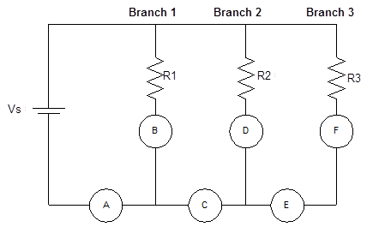

|  |  |  |  |  |
| --- | --- | --- | --- | --- |
|  | **R** | **E** | **I** | **P** |
| R1 |  |  |  |  |
| R2 |  |  |  |  |
| R3 |  |  |  |  |
| T |  |  |  |  |

*Design Table*

|  |  |  |  |  |
| --- | --- | --- | --- | --- |
|  | **R** | **E** | **I** | **P** |
| R1 |  |  |  |  |
| R2 |  |  |  |  |
| R3 |  |  |  |  |
| T |  |  |  |  |

*Quantities Table*

IA = _________

IB = _________

IC = _________

ID = _________

IE = _________

IF = _________